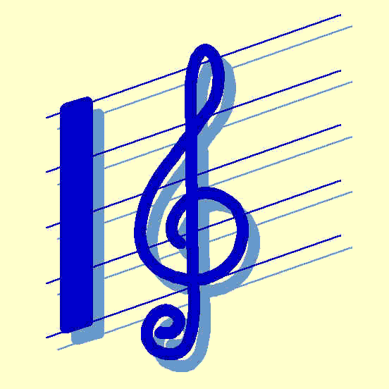

October 21, 2010

Dear Parents and Students,

Congratulations on being selected for the 2010 NYSSMA Junior High Area-All-State Band or Orchestra. The ensembles will rehearse at Frontier High School on Friday, November 5, 2010 and Saturday, November 6, 2010. The concerts on Saturday November 6 are at 1:00 pm (chorus, jazz, string orchestra) and 4:00 pm (full orchestra, band).
On Friday 11/5/10, the bus will depart from Barker at 2:20 pm. Students will be at Frontier High School until 9:00 pm. Meals will be provided for those students who have ordered; those who did not order should bring a bagged meal. Snacks will be available so students may bring money for that if they wish. Students will return to Barker at approximately 10:15 pm and will need transportation home at that time.
On Saturday 11/6/10, the bus will depart for Frontier High School at 7:30 am. Lunch provided as per orders; bring your own if you did not order. There will NOT be a return bus. Parents are responsible for their son/daughter after the concerts have concluded. If you have any questions or concerns regarding this event, please contact us at 795-3201 ext. 7189 or cjohnson@barkercsd.net .
A full schedule of the weekend is attached. We are very proud of all students selected to Area-All-State. Thank you for your support.

Please sign and detach at the bottom and return to Mrs. Johnson by Tuesday,
November 2, 2010.

Sincerely,

Cheryl Johnson
Barker Bands
We, the student and the parent, have read the information above regarding NCMEA County Band Festival and are committed to these times and dates for the rehearsals and concert. I give permission for my son/daughter _______________________to make the above bus trips at the designated times.

Parent Signature________________________ Student Signature__________________________

Date ____________________________

